Software Requirements Specification (SRS)

Version 1.0

February 14, 2026

Hotel Reception Management System

Ali Awdallah
Abdulrahman Babkir Diya Rafat

DACS3203 Secure Software Development

Introduction

Purpose
This Software Requirements Specification (SRS) document defines the functional requirements, abuse cases, and security requirements for the Hotel Reception Management System.
The purpose of this document is to provide a clear and structured description of system behavior, security threats, and mitigation mechanisms. It serves as a reference for
system design, development, and evaluation.

Scope
The Hotel Reception Management System is a desktop-based application developed using Java and JavaFX. The system is intended for use by hotel reception staff and managers to manage room reservations, guest check-ins and check-outs, billing, and service requests.
The system stores and retrieves data from a centralized database and implements security mechanisms to protect guest information and financial records.
The system does not provide direct access to guests; all operations are performed by authorized hotel staff.

System Overview
The system provides the following core functionalities:
    - User authentication
    - Room availability search
    - Reservation management
    - Guest check-in and check-out
    - Payment recording
    - Service request logging
    - Daily reporting for management
The system also incorporates security mechanisms such as authentication
enforcement, role-based access control, audit logging, and data backup procedures.

Overall Description
  - System Environment
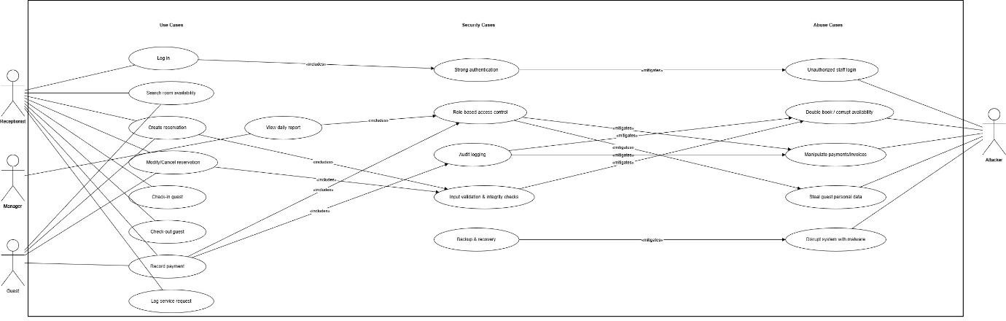

Functional Requirements

High-Level Functional Requirements
The system shall provide controlled user authentication for authorized personnel. The system shall allow receptionists to search for available rooms based on date range and room type. The system shall enable creation, modification, and cancellation of reservations. The system shall support guest check-in and check-out processes. The system shall calculate billing amounts and record guest payments. The system shall allow logging of guest service requests. The system shall provide managers with access to daily operational reports.

Functional Use Case Diagram
This section presents the UML functional use case diagram illustrating the interaction between system actors and the functional use cases identified in this document. The
diagram visually represents how receptionists and managers interact with the system to perform operational tasks.

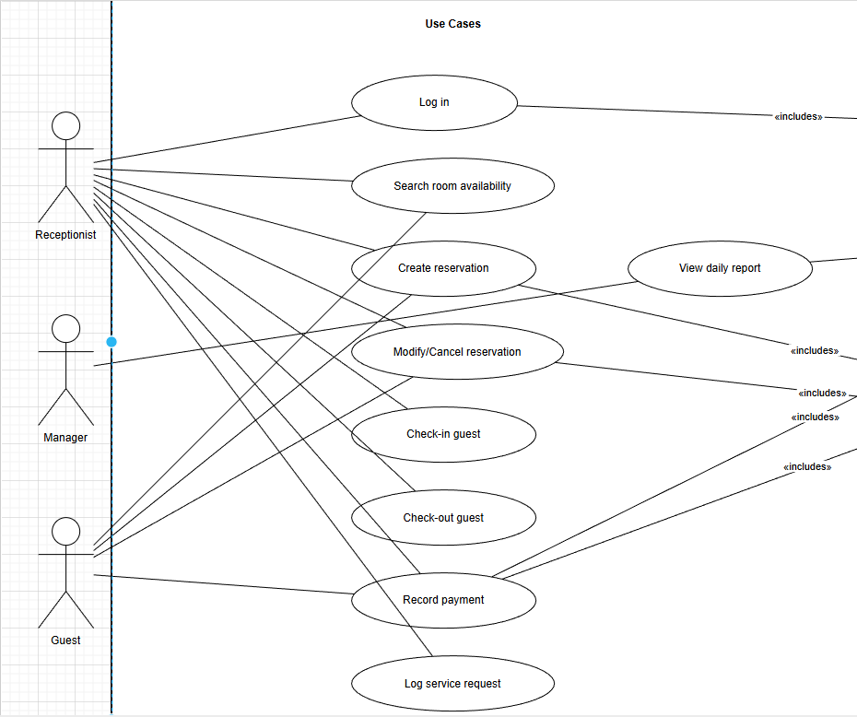

Functional Use Case Documentation
This section provides detailed descriptions of all functional use cases of the Hotel Reception Management System. Each use case specifies the primary actor,
preconditions, triggers, main flow of events, alternative flows where applicable, and postconditions.

Normal Use Case

Use case Id: | F001
Name: | Log in
Created By/Author: | Abdulrahman
Date Created: | 14 Feb 2026
Actor: | Receptionist, Manager, Guest
Description/Summary: | A user shall authenticate with the hotel reservation system using a username and password so that they can access  functions according to their role.
Preconditions: | - The system is running and reachable.  - A user account with username and password exists.

Postconditions: | - A session is created for the authenticated user.  - The dashboard corresponding to the user’s role is displayed.
Normal course of events: | - The user opens the application and selects “Log in”.  - The user enters username and password.  - The system validates the credentials.  - If valid, the system creates a session and displays the user’s dashboard.
Exceptions: | - 3a. Invalid credentials: The system shows an error message and allows the user to retry.  - 3b. Account disabled or locked: The system shows a message indicating that access is denied and does not create a session.
Acceptance Criteria: | - The system shall grant access only when the  entered username and password exactly match one active user account.  - The system shall lock the user account after 5 consecutive failed login attempts within any 10-minute period.  - After successful login, the dashboard shall be  displayed within 2 seconds on a standard front-desk PC.

Use case Id: | F002
Name: | Search room availability
Created By/Author: | Ali
Date Created: | 14 Feb 2026
Actor: | Receptionist, Guest
Description/Summary: | The actor shall search for available rooms by date range and criteria so that suitable rooms can be selected for reservation.

Preconditions: | - The actor is authenticated or identified.  - Room inventory and reservations exist in the system database.
Postconditions: | - A list of rooms that match the criteria and are available for the specified dates is displayed.  - No reservation is created by this use case.
Normal course of events: | - The actor selects “Search availability”.  - The actor enters check-in date, check-out date, number of guests, and optionally room type.  - The system validates the dates and input.  - The system checks existing reservations and room statuses.  - The system displays a list of available rooms with basic rate information.
Exceptions: | - 3a. Invalid dates (check-out before check-in or dates in the past): The system shows an error and asks the actor to correct the dates.  - 5a. No rooms available: The system displays a “No availability” message and suggests the actor adjust dates or room type.
Acceptance Criteria: | - For a database containing up to 500 rooms, the system shall display availability results within 2 seconds in at least 95% of searches.  - The system shall never display a room as available if there exists an active reservation for that room with overlapping dates with the requested range.  - If no rooms match, a clear “No availability” message shall be shown on the results screen without  requiring application restart.

Use case Id: | F003
Name: | Create reservation
Created By/Author: | Diya
Date Created: | 14 Feb 2026
Actor: | Receptionist, Guest
Description/Summary: | The actor shall create a reservation by selecting dates,  room, and guest details so that the booking is stored and a confirmation is generated.
Preconditions: | - The actor is authenticated or identified.  - Room and rate information exist in the system.  - Requested dates are valid.
Postconditions: | - A new reservation record with a unique reservation ID is stored in the database.  - The selected room is marked as reserved for the specified date range.
Normal course of events: | - The actor selects “Create reservation”.  - The actor enters or confirms check-in date, check-out date, and number of guests.  - The system validates the dates.  - The system retrieves and shows available rooms and rates.  - The actor selects a room.  - The actor enters mandatory guest details (name, contact information, ID or passport number).  - The system calculates the total price and displays a summary.  - The actor confirms the reservation.  - The system stores the reservation and shows the reservation ID and confirmation detail

Exceptions: | - 3a. Invalid dates: The system rejects the input and asks the actor to correct the dates.  - 4a. No rooms available: The system informs the actor that no rooms are available for the given dates.  - 6a. Required guest details missing or invalid: The  system highlights missing/invalid fields and requires corrections before proceeding.
Acceptance Criteria: | - For valid input, the system shall store the reservation and display the reservation ID within 3 seconds of the actor confirming.  - The system shall require guest name, at least one contact method, and at least one ID/passport field to be non-empty before allowing reservation confirmation.  - The system shall reject and not save any reservation that would cause two active reservations with overlapping date ranges for the same room.

Use case Id: | F004
Name: | Modify/Cancel reservation
Created By/Author: | Abdulrahman
Date Created: | 14 Feb 2026
Actor: | Receptionist, Guest
Description/Summary: | The actor shall modify or cancel an existing reservation so that booking information remains accurate and up-to-date.
Preconditions: | - The actor is authenticated.  - A reservation with the given ID exists in the system.
Postconditions: | - For modification: the reservation record is updated with new data.

 | - For cancellation: the reservation status is set to “Cancelled” and the room is freed for the affected date range.
Normal course of events: | - The actor searches for a reservation by ID or guest details.  - The system displays the reservation information.  - The actor chooses to modify or cancel the reservation.  4a. Modify: The actor edits allowed fields (dates, room, contact details, notes).  4b. Cancel: The actor confirms cancellation.  - The system validates the changes and checks for room/date conflicts.  - The system saves modifications or updates status to “Cancelled” and displays the updated status.
Exceptions: | - 1a. Reservation not found: The system shows  “Reservation not found” and does not proceed.  - 5a. New dates create an overlap with another active reservation for the same room: The system rejects the changes and shows a conflict message.  - 4b. Cancellation not allowed due to policy (for example, after check-in): The system shows a message and does not cancel the reservation.
Acceptance Criteria: | - After a successful modification or cancellation, the updated status and details shall appear to the actor within 2 seconds.  - Every modification or cancellation shall create an audit log entry containing user ID, timestamp, reservation ID, and action type.  - The system shall prevent any modification that  would create overlapping reservations for the same room and date range.

Use case Id: | F005
Name: | Check-in guest
Created By/Author: | Ali
Date Created: | 14 Feb 2026
Actor: | Receptionist
Description/Summary: | The receptionist shall check a guest into the hotel by confirming their reservation and assigning a room so that the room becomes occupied and the guest is marked as in-house.
Preconditions: | - The receptionist is logged in.  - A reservation exists for the guest with a check-in  date equal to or earlier than the current date and not already checked in or cancelled.  - At least one suitable room is available or already assigned to the reservation.
Postconditions: | - The reservation status is updated to “Checked-in”.  - The assigned room status is updated to “Occupied”.
Normal course of events: | - The receptionist searches for the guest’s reservation.  - The system displays reservation details and room assignment.  - The receptionist verifies the guest’s identity using ID/passport.  - If no room is assigned, the receptionist selects an available room.  - The receptionist confirms check-in.  - The system records the check-in time, updates reservation status to “Checked-in”, and sets room status to “Occupied”.

Exceptions: | - 1a. Reservation not found: The system shows “Reservation not found”; the receptionist may create a walk-in reservation separately.  - 4a. Assigned room out of service: The receptionist selects another available room; the system updates the assignment.  - 3a. Identity mismatch: The receptionist cancels the check-in operation and asks for clarification or  additional documentation.
Acceptance Criteria: | - For a valid reservation, the system shall complete status changes to “Checked-in” and “Occupied” within 3 seconds after the receptionist confirms.  - After check-in, the guest shall appear in the  “in-house guests” list and the assigned room shall be shown as “Occupied” in room-status views.  - The system shall prevent check-in for any reservation whose status is “Cancelled” or whose check-out date is earlier than the current date.

Use case Id: | F006
Name: | Check-out guest
Created By/Author: | Diya
Date Created: | 14 Feb 2026
Actor: | Receptionist
Description/Summary: | The receptionist shall check a guest out, finalize their charges, and update room status so that the stay is closed and billing is complete.
Preconditions: | - The receptionist is logged in.  - The guest is currently checked in with an active reservation.

Postconditions: | - The reservation status is updated to “Checked-out”.  - A final invoice is stored.  - The room status is updated to “Needs cleaning” or “Vacant” according to hotel policy.
Normal course of events: | - The receptionist selects the guest from the list of in-house guests.  - The system retrieves room charges, nights stayed, and extra charges.  - The system calculates the total amount due and displays an invoice.  - The receptionist confirms check-out and records payment using F007.  - The system sets reservation status to “Checked-out” and updates room status.
Exceptions: | - 2a. Missing or incorrect extra charges: The receptionist corrects charges and the system recalculates.  - 4a. Guest cannot pay full amount: The receptionist follows hotel procedures (partial payment, manager approval, or blocking check-out) and records the  decision.
Acceptance Criteria: | - For a valid check-out, the system shall calculate charges, record payment, and update reservation and room statuses within 3 seconds of  confirmation.  - Each checked-out stay shall have at least one final invoice record retrievable by reservation ID.  - The room previously occupied by the guest shall no longer appear as “Occupied” in any room-status  view immediately after check-out.

Use case Id: | F007
Name: | Record payment
Created By/Author: | Abdulrahman
Date Created: | 14 Feb 2026
Actor: | Receptionist, Guest
Description/Summary: | The actor shall record a payment against a guest’s folio so that the outstanding balance and financial records are  accurate.
Preconditions: | - A reservation or folio with an outstanding balance exists.  - The actor is authenticated.
Postconditions: | - A payment entry is stored with all details.  - The outstanding balance is updated.
Normal course of events: | - The actor opens the guest’s billing/folio screen.  - The system shows current charges and outstanding balance.  - The actor selects payment method and enters amount and optional reference number.  - The system validates amount and method.  - The system stores the payment and updates the remaining balance.  - The system can display or print a receipt for the guest.
Exceptions: | - 4a. Amount negative or zero: The system rejects the input and requests a valid positive amount.  - 4b. Amount greater than outstanding balance: The system rejects or prompts for confirmation of overpayment as per policy.  - 4c. Card or external payment failure: The system does not store the payment and shows a failure message.

Acceptance Criteria: | - For each successful payment, the system shall store reservation ID, user ID, date/time, method, and amount within 2 seconds after confirmation.  - The outstanding balance shown after recording the payment shall equal Total charges – Sum of  payments with a maximum rounding difference of  0.01 in the hotel currency.  - The system shall not allow payments with zero or negative amounts and shall not reduce the  outstanding balance below zero without managerial override.

Use case Id: | F008
Name: | Log service request
Created By/Author: | Ali
Date Created: | 14 Feb 2026
Actor: | Receptionist, Guest
Description/Summary: | The actor shall log a service request (such as housekeeping or maintenance) for a guest room so that staff can track  and resolve issues.
Preconditions: | - The actor is authenticated or identified.  - The room or reservation exists.
Postconditions: | - A service request record is created with initial status “Open”.
Normal course of events: | - The actor selects “New service request”.  - The actor selects a room or guest reservation.  - The actor chooses request type (e.g., housekeeping, maintenance) and enters a description.  - The system stores the request with timestamp, status “Open”, and requester identity.  - Staff later update status to “In progress” or “Closed” via a separate workflow.

Exceptions: | - 2a. Room or reservation not found: The system displays an error and does not create a request.  - 3a. Description empty: The system requires a non-empty description before saving.
Acceptance Criteria: | - The system shall create the service request record and show its ID within 2 seconds after the actor submits the form.  - Each service request shall be associated with exactly one room or reservation and one initial type.  - The system shall allow staff to view all “Open” and “In progress” requests filtered by room or status at any time.

Use case Id: | F009
Name: | View daily report
Created By/Author: | Diya
Date Created: | 14 Feb 2026
Actor: | Manager
Description/Summary: | The manager shall view a daily operational report so that arrivals, departures, occupancy, and revenue are monitored.
Preconditions: | - The manager is logged in.

 | - Reservations and payments data exist for the selected date.
Postconditions: | A report summary is displayed and optionally available for export or printing.
Normal course of events: | - The manager opens the “Reports” menu and selects “Daily summary”.  - The manager selects a report date (default today).  - The system retrieves relevant reservations and payments for that date.  - The system calculates arrivals, departures, in-house count, occupancy percentage, and total revenue.  - The system displays the daily report and optionally offers export or print options.
Exceptions: | - 3a. No data for the chosen date: The system shows a report with zero counts and a note that no activity exists.
Acceptance Criteria: | - For a day with up to 500 reservations, the system shall generate and display the daily report within 5 seconds.  - The totals in the report (arrivals, departures,  in-house count, revenue) shall match the underlying reservations and payments when recalculated  manually.  - Only users with the Manager role shall be able to access the daily report screen.

Abuse Cases

Abuse Case Diagram
This section presents the abuse case diagram identifying potential misuse scenarios that may threaten the system’s functionality, data integrity, confidentiality, or availability. The diagram illustrates how malicious actors may attempt to exploit system vulnerabilities and which functional use cases are targeted.

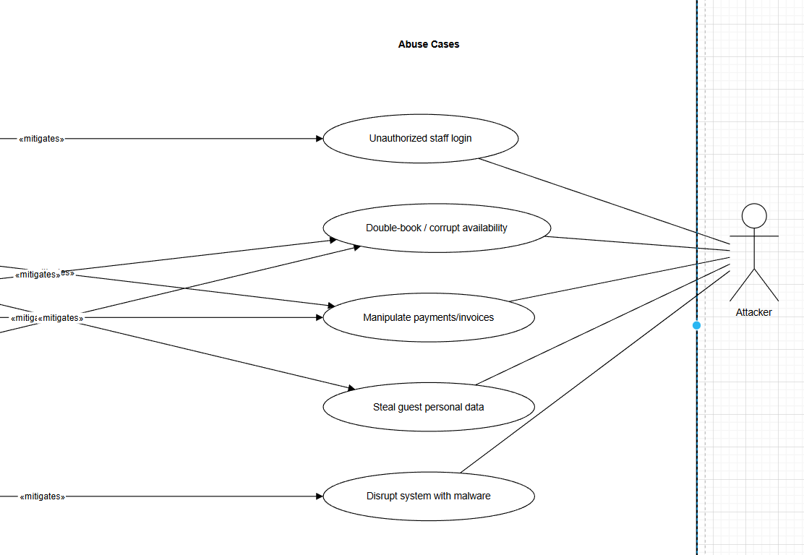

Abuse Case Documentation
This section describes potential misuse scenarios that could compromise system security. Each abuse case identifies the malicious actor, describes the threat scenario, outlines the potential impact, and references the related functional use cases that are targeted.

Abuse Cases

Abuse case Id: | A001
Name: | Unauthorized staff login
Created By/Author: | Ali

Date: | 14 Feb 2026
Priority: | High
Scope: | Login function and all staff-only features of the hotel reservation system.
Development Environment: | Desktop application at hotel front desks connected to the central database.
Mis-actors: | External attacker, malicious guest, or any other user attempting to impersonate staff.
Access Right Levels: | Low/Medium level system users (receptionists, managers).
Point of Entry: | Login screen of the hotel reservation system.
Security Attributes Affected: | Confidentiality, Integrity, Availability.
Description: | An attacker gains staff-level access by guessing,  brute-forcing, or stealing staff credentials, then logs in and uses the system as a receptionist or manager.
Sophistication: | Simple to moderate; relies on weak passwords, reuse of credentials, or social engineering.
Preconditions: | - Staff accounts exist in the system.  - The attacker can access a workstation or remote interface presenting the login screen.
Assumptions: | - Passwords may be weak or reused.  - Login attempts may not be strictly limited without the mitigating security case.
Postconditions: | - The attacker has an active staff session and can access staff-only functions.
Related Use Cases: | - F001 / Log in
Related Threats: | - Account takeover, unauthorized reservations and cancellations, privacy breaches, fraud.
Exceptions: | None
Acceptance Criteria: | - The attacker can successfully authenticate as a  staff account using non-legitimate means and then

perform at least one staff-only function (for example, view guest profiles or modify a reservation) in the same session.

Abuse case Id: | A002
Name: | Create overlapping reservation (double-booking)
Created By/Author: | Abdulrahman
Date: | 14 Feb 2026
Priority: | High
Scope: | Reservation creation and modification functionality and room inventory data.
Development Environment: | Desktop reservation application connected to the reservation database.
Mis-actors: | Malicious receptionist, or attacker using a compromised receptionist account.
Access Right Levels: | Low/Medium level system users (front-desk staff).
Point of Entry: | “Create reservation” and “Modify reservation” screens.
Security Attributes Affected: | Integrity, Availability.
Description: | The mis-actor creates or modifies reservations so that more than one active reservation exists for the same room and overlapping date range, intentionally causing conflicts or chaos.
Sophistication: | Simple; requires basic knowledge of how to enter dates and select rooms.
Preconditions: | - Mis-actor is logged in with permission to create and modify reservations.  - The system lacks or bypasses proper overlap validation.
Assumptions: | - Hotel staff may not immediately notice the conflict until guests arrive.

Postconditions: | - At least two active reservations exist for the same room with overlapping dates.
Related Use Cases: | - F003 / Create reservation  - F004 / Modify/Cancel reservation
Related Threats: | - Operational disruption, guest dissatisfaction, possible fraud.
Exceptions: | None.
Acceptance Criteria: | - The mis-actor can save a reservation or  modification that results in two or more active reservations for the same room with overlapping dates, and the system does not display any conflict warning at the time of saving.

Abuse case Id: | A003
Name: | Manipulate payments and invoices
Created By/Author: | Diya
Date: | 14 Feb 2026
Priority: | High
Scope: | Billing, payment, and invoice-generation functionality.
Development Environment: | Front-desk application and associated financial database tables.
Mis-actors: | Malicious receptionist or attacker with stolen receptionist/manager credentials.
Access Right Levels: | Medium level system users (staff allowed to edit payments and charges).
Point of Entry: | Payment recording screens, invoice adjustment interfaces.

Security Attributes Affected: | Integrity, Confidentiality.
Description: | The mis-actor modifies or deletes payment records or changes room charges and discounts to misappropriate funds or hide fraud.
Sophistication: | Moderate; requires understanding of where financial data is stored and how it affects balances.
Preconditions: | - Mis-actor is logged in with privileges to edit payments or charges.  - The system does not require higher-level approval for key billing changes.
Assumptions: | - Audit logs or reports are not regularly reviewed, or they do not provide enough detail.
Postconditions: | - Stored payment and invoice data no longer reflect the actual money received or amounts owed.
Related Use Cases: | - F006 / Check-out guest  - F007 / Record payment
Related Threats: | - Financial loss, incorrect revenue reporting, internal fraud.
Exceptions: | - None.
Acceptance Criteria: | - The mis-actor can alter at least one existing payment or charge so that the guest’s final invoice total differs from the original agreed amount by more than 5% without triggering any automatic alert or access-denied message from the system.

Abuse case Id: | A004
Name: | Steal guest personal data
Created By/Author: | Ali
Date: | 14 Feb 2026
Priority: | High

Scope: | Guest profile, reservation details, and reporting functions containing personal information.
Development Environment: | Hotel reservation database and its desktop client.
Mis-actors: | External attacker with compromised staff account, or malicious insider.
Access Right Levels: | Medium/High level system users (receptionists, managers).
Point of Entry: | Guest profile screens, reservation search, export features, and reporting screens.
Security Attributes Affected: | Confidentiality.
Description: | The mis-actor accesses and exports guest contact details, ID/passport numbers, and stay history for use outside the hotel, such as selling data or using it for scams.
Sophistication: | Moderate; may involve repeated queries, screenshots, or use of an export function.
Preconditions: | - Mis-actor can log in with staff privileges.  - The system allows unrestricted viewing or exporting of detailed guest lists.
Assumptions: | - There are no limits on the number of guest records that can be retrieved or exported in one operation.
Postconditions: | - The mis-actor has a copy of personal data for multiple guests outside the control of the hotel system.
Related Use Cases: | - F003 / Create reservation  - F004 / Modify/Cancel reservation  - F009 / View daily report
Related Threats: | - Privacy violations, identity theft, regulatory fines.
Exceptions: | - None.
Acceptance Criteria: | - In a single session, the mis-actor can obtain the full  names and contact details for at least 50 distinct

guests from the system using normal user interfaces without being blocked or logged out.

Abuse case Id: | A005
Name: | Disrupt system with malware/ransomware
Created By/Author: | Abdulrahman
Date: | 14 Feb 2026
Priority: | High
Scope: | Front-desk workstations and the central reservation database.
Development Environment: | Hotel desktops running the reservation system and connected to networked storage.
Mis-actors: | External attacker using phishing or infected media, or insider introducing malware.
Access Right Levels: | Other network users and infected staff accounts.
Point of Entry: | Malicious email attachments, compromised websites, or infected USB devices used on hotel machines.
Security Attributes Affected: | Availability, Integrity, Confidentiality.
Description: | Malware or ransomware executes on hotel systems,  encrypting or deleting reservation and financial data and preventing normal operation of the reservation system.
Sophistication: | Moderate to advanced; may use social engineering and exploitation of unpatched software.
Preconditions: | - Staff use email or web browsing on machines that also run the reservation system.

 | - Endpoint protection and backup measures may be inadequate.
Assumptions: | - Users may open attachments or run executables from untrusted sources.
Postconditions: | - The reservation system becomes partially or fully unusable, and key data is inaccessible or corrupted.
Related Use Cases: | - All operational use cases requiring system availability.
Related Threats: | - Prolonged downtime, data loss, ransom demands.
Exceptions: | None
Acceptance Criteria: | - After executing the malware on a front-desk  machine, staff are unable to log in or retrieve any reservations from that machine and reservation data on the main database cannot be read without special recovery actions.

Security Requirements

Security Use Case Diagram
This section presents the security use case diagram, which illustrates the security mechanisms implemented to mitigate the identified abuse cases. The diagram
demonstrates how each security control addresses specific threats and protects related functional use cases.

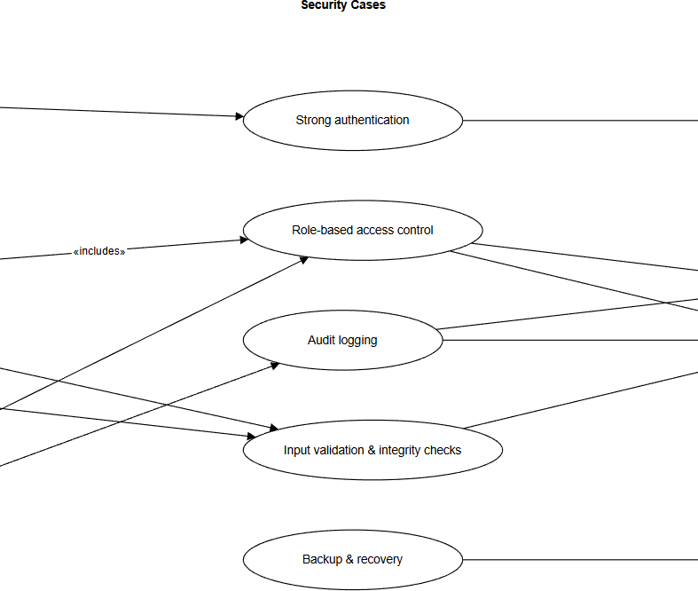

Security Use Case Documentation
This section defines the security mechanisms implemented within the system to mitigate identified threats and ensure protection of system assets. Each security use case specifies the security objective, associated abuse cases it mitigates, and the mechanism used to enforce protection.

Security cases

Use case Id: | S001
Name: | Strong authentication for staff accounts
Created By/Author: | Diya
Date Created: | 14 Feb 2026
Actor: | The hotel reservation system
Description/Summary: | The system shall enforce strong authentication for staff accounts by applying password rules, limiting login  attempts, and optionally requiring a second factor so that unauthorized logins are reduced.
Preconditions: | - Staff user accounts exist.  - A user initiates the F001 Log in use case.
Postconditions: | - Only users who satisfy all authentication checks obtain a valid session.  - Accounts with repeated failed attempts are temporarily locked.
Normal course of events: | - The user enters username and password.  - The system verifies that the password meets configured policy and that it matches the stored password for that user.  - If multi-factor authentication is enabled, the system prompts the user for a second factor (for example, OTP) and verifies it.  - The system creates a session and records a successful login event in the audit log.
Exceptions: | - 2a. Password does not match or user does not exist:  The system rejects the login and increments the failed-attempt counter.  - 2b. Password expired or does not meet policy: The system requires the user to change the password or contact an administrator.

- 3a. Second factor invalid or missing: The system denies access and does not create a session.
- 2c. Failed attempts exceed configured threshold (for example, 5 attempts in 10 minutes): The system
locks the account for a configurable lockout period (for example, 15 minutes).
Acceptance Criteria: | - The system shall lock a staff account for at least 15 minutes after 5 failed login attempts within any  10-minute window.  - When multi-factor authentication is enabled, the system shall not create a session unless both  password and second factor are valid.  - All successful and failed login attempts shall be recorded with user identifier (or attempted ID), timestamp, and success/failure flag.

Use case Id: | S002
Name: | Role-based access control
Created By/Author: | Abdulrahman
Date Created: | 14 Feb 2026
Actor: | The hotel reservation system
Description/Summary: | The system shall apply role-based permissions so that  each user can only access features and data appropriate to their role (Guest, Receptionist, Manager).
Preconditions: | - The user is authenticated.  - Each account has a predefined role.
Postconditions: | - Only operations permitted by the user’s role can be executed during the session.
Normal course of events: | - After login, the system reads the role associated with the user account.  - The system enables or disables menus and screens based on that role.

- When the user requests a protected operation (such as editing a payment or viewing detailed reports), the system checks whether the user’s role is authorized.
- If authorized, the system performs the operation; otherwise, it denies access and may log the attempt.
Exceptions: | - 3a. Unauthorized role for the requested operation:  The system shows an “Access denied” message and records the attempt in the audit log.
Acceptance Criteria: | - Guests shall never be able to access any screens that show other guests’ personal details or internal reports.  - Receptionists shall not be able to change application configuration or view aggregated financial reports reserved for managers.  - At least 95% of attempted unauthorized accesses to protected operations during tests shall be blocked with “Access denied” and recorded in the audit log.

Use case Id: | S003
Name: | Audit logging of sensitive actions
Created By/Author: | Ali
Date Created: | 14 Feb 2026
Actor: | The hotel reservation system
Description/Summary: | The system shall record an audit log entry for sensitive actions such as login attempts, reservation  creation/modification/cancellation, payment and invoice changes, and role changes so that suspicious activity can be traced.
Preconditions: | - The logging mechanism is enabled and has write access to the audit log store.

Postconditions: | - Each sensitive action results in an audit record containing key details.
Normal course of events: | - A user performs a sensitive action (for example, creates a reservation, modifies a payment, or cancels a booking).  - The system creates an audit entry including at least: user ID, timestamp, action type, affected record  identifier, and success/failure status.  - The system writes the entry to a protected audit log.  - An administrator or manager can later retrieve and review audit logs via a reporting interface or external tools
Exceptions: | - 3a. Audit log storage unavailable: The system  queues audit entries in memory and retries writing them until storage becomes available, or blocks sensitive actions if queuing is not possible.
Acceptance Criteria: | - For all sensitive actions listed in the requirements, 100% of successful and failed attempts during  system tests shall produce corresponding audit entries.  - Audit entries shall be tamper-resistant: normal application users shall not have any function that allows them to edit or delete existing audit records.  - Audit logs for at least the last 30 days shall be  retrievable and filterable by user ID and action type.

Use case Id: | S004
Name: | Validate reservation dates and prevent double-booking
Created By/Author: | Diya

Date Created: | 14 Feb 2026
Actor: | The hotel reservation system
Description/Summary: | The system shall validate reservation dates and room selection for all create/modify operations and reject any  reservation that overlaps with another active reservation for the same room.
Preconditions: | - A user is executing F003 Create reservation or F004 Modify/Cancel reservation.  - The system can query existing reservation data.
Postconditions: | - Only non-conflicting reservations are saved in the database.
Normal course of events: | - The calling use case sends the proposed room number, check-in date, and check-out date to the validation component.  - The system retrieves all active reservations for that room whose dates overlap with the requested range.  - The system evaluates whether any overlap exists.  - If no overlap is found, the system returns “valid” and allows the caller to save the reservation.
Exceptions: | - 3a. Overlap detected: The system returns an error message indicating that the room is already  reserved for the selected dates and prevents saving.  - 2a. Reservation data store unavailable: The system returns an error to the caller and does not allow saving the reservation until validation can be completed.
Acceptance Criteria: | - During testing, attempts to create or modify reservations to overlap for the same room and dates shall be blocked 100% of the time.  - The validation step shall complete in less than 1 second for a database containing up to 10,000 reservations.

- The system shall not contain more than one active reservation with overlapping dates for any given
room at any time.

Use case Id: | S005
Name: | Backup
Created By/Author: | Abdulrahman
Date Created: | 14 Feb 2026
Actor: | The hotel reservation system
Description/Summary: | The system shall perform regular backups of reservation, guest, and financial data and provide a means to back them so that operations can be recovered after data loss or ransomware attacks.
Preconditions: | - Backup storage location is configured and accessible.  - Sufficient disk space is available for storing backups.
Postconditions: | - At least one recent, verified backup exists for critical data.
Normal course of events: | - According to a schedule (for example, every night at 02:00), the system selects all critical datasets (reservations, guest profiles, payments,  configuration).  - The system creates a backup file and writes it to the configured backup storage.  - The system verifies the integrity of the backup file (for example, using checksums) and logs the result.

Exceptions: | - 2a. Backup storage unavailable or full: The system logs a backup failure event and notifies an  administrator; the next scheduled backup attempts again.
Acceptance Criteria: | - The system shall create at least one full backup of critical data every 24 hours.  - In test restoration scenarios, the system shall  recover critical data to a consistent state using the latest valid backup within 30 minutes for a database of up to 1 GB.  - No more than 24 hours of reservation, guest, or payment data shall be permanently lost in the event of a single system failure, assuming the last backup completed successfully.

